**ITEM FOUR**

**SCIENCE**

*Time : 2:15minutes*

**Candidate ’s name :…………………………………………… Stream……………........**

**Index No…………………………………………………………………………….**

**SECTION MARKS**

**B**

**A**

**DO NOT OPEN THIS BOOKLET UNTIL YOU ARE TOLD TO DO SO**

**Read the following instructions carefully.**

**T**

1. **Read the instructions carefully**

1. **Answer ALL questions in Section A & B**
2. **Answers should be put in the space provided.**
3. **All answers should be written in blue or black ink.**
4. **Unnecessary alterations may lead to loss of marks**
5. **Any handwriting that cannot be read may lead to loss of marks.**

**SECTION A(40 MARKS)**

1. Name any one non flowering plant.

_________________________________________________________

1. How is the immunization programme important to people in Uganda?

_________________________________________________________

1. Identify any one way of controlling water borne diseases.

_________________________________________________________

1. Name any one food stuff that is pounded or ground before cooking.

_________________________________________________________

1. State any one difference between a dove and a rat.

_________________________________________________________

1. Give an example of a water impurity.

_________________________________________________________

1. Mention any one reason why children eat food.

_________________________________________________________

**Study the diagram of a fruit below and answer questions 8 and 9**

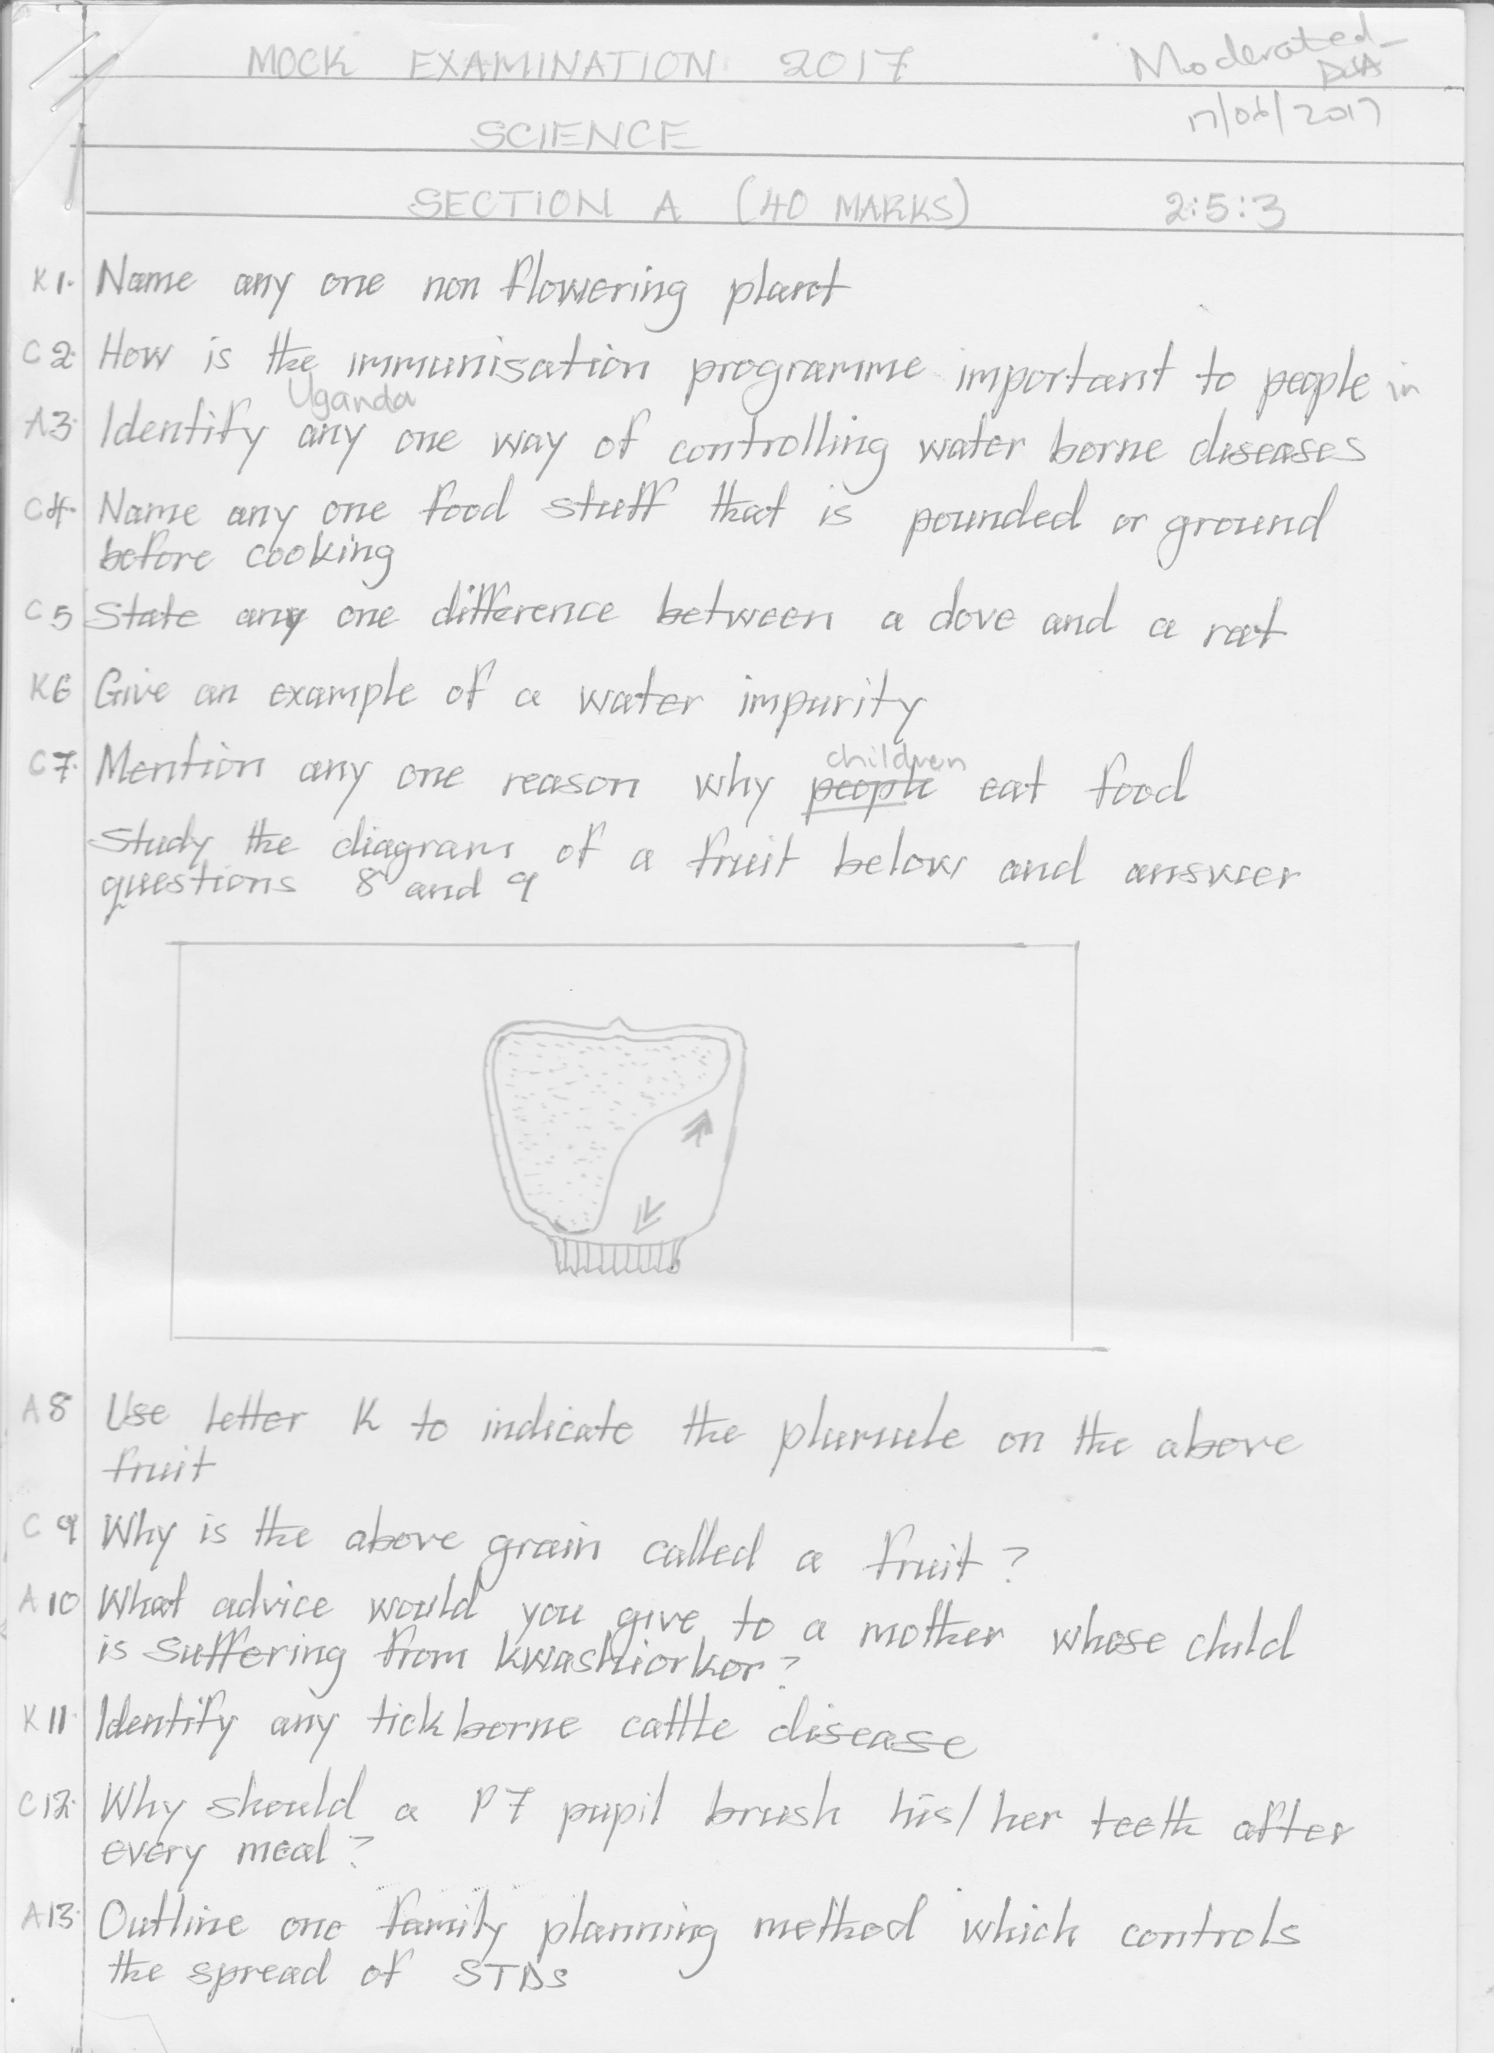

1. Use letter K to indicate the plumule on the above fruit.

_________________________________________________________

1. Why is the above grain called a fruit?

_________________________________________________________

1. What advice would you give to a mother whose child is suffering from kwashiorkor?

_________________________________________________________

1. Identify any tick-borne cattle disease.

_________________________________________________________

1. Why should a P.7 pupil brush he/ her teeth after every meal?

_________________________________________________________

1. Identify the best family planning method which controls STDs among

married couples.

_________________________________________________________

1. Besides killing germs, how else is hydrochloric acid important in the

stomach?

_________________________________________________________

1. Why are bee keepers advised to put be hives in quiet places?

_________________________________________________________

1. Suggest one way of controlling burns and scalds in a kitchen.

_________________________________________________________

1. Give the meaning of refraction of light.

_________________________________________________________

1. State one importance of proper chewing of food before swallowing.

_________________________________________________________

1. Cite out one way of increasing the volume of blood in the body.

_________________________________________________________

_________________________________________________________

1. Besides being vertebrates, how else are birds similar to mammals?

_________________________________________________________

1. List any one solute used in the preparation of ORS.

_________________________________________________________

1. Why isn’t a toadstool able to make its own food?

_________________________________________________________

1. Suggest any one way of controlling mosquitoes at the larva stage.

_________________________________________________________

1. How are splints useful to a casualty?

_________________________________________________________

1. Outline one way of controlling constipation among children.

_________________________________________________________

1. In one sentence, give the meaning of an apiary.

_________________________________________________________

1. How do crops on a mixed farm benefit from livestock?

_________________________________________________________

1. In the space below, draw a compound trifoliate leaf.
2. Why should babies be breastfed for the first six months of their life?

_________________________________________________________

1. Give one difference between a spider and a cockroach.

_________________________________________________________

_________________________________________________________

1. Name any one incandescent object.

_________________________________________________________

1. State one way how machines simplify work.

_________________________________________________________

1. Why can’t a pen write on a paper smeared with oil?

_________________________________________________________

**Study the diagram below and answer questions 34 and 35.**

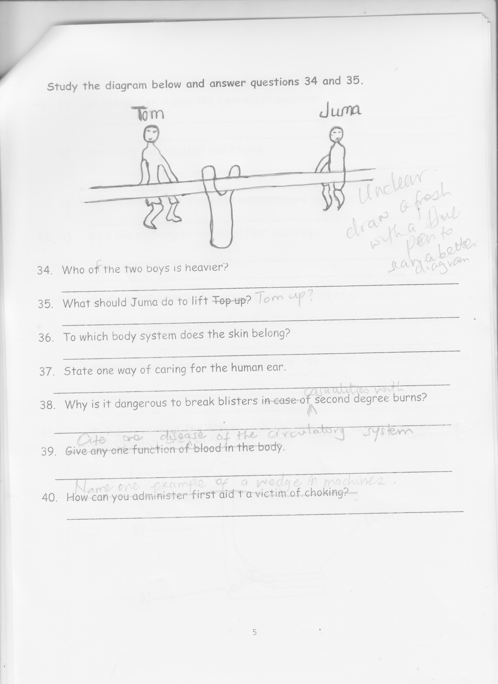

1. Who of the two boys is heavier?

_________________________________________________________

1. What should Juma do to lift Tom up?

_________________________________________________________

1. To which body system does the skin belong?

_________________________________________________________

1. State one way of caring for the human ear.

_________________________________________________________

1. Why is it dangerous to break blisters casualties with second degree burns?

_________________________________________________________

1. Cite one disease of the circulatory system.

_________________________________________________________

1. Name one example of a wedge in machines.

_________________________________________________________

**SECTION B (60 MARKS)**

1. a) In one sentence give the meaning of weather.

_____________________________________________________

_____________________________________________________

b) State any two weather conditions.

i)____________________________________________________

ii)___________________________________________________

c) Which instrument is used to measure wind speed?

_____________________________________________________

1. a) Give the meaning of the term food security.

__________________________________________________________________________________________________________

b) State any two ways of improving food security of a community.

i)___________________________________________________

ii)__________________________________________________

c) State one danger of food insecurity in a community.

__________________________________________________________________________________________________________

1. **Below is part of the human skeleton, use it to answer the following**

**questions**

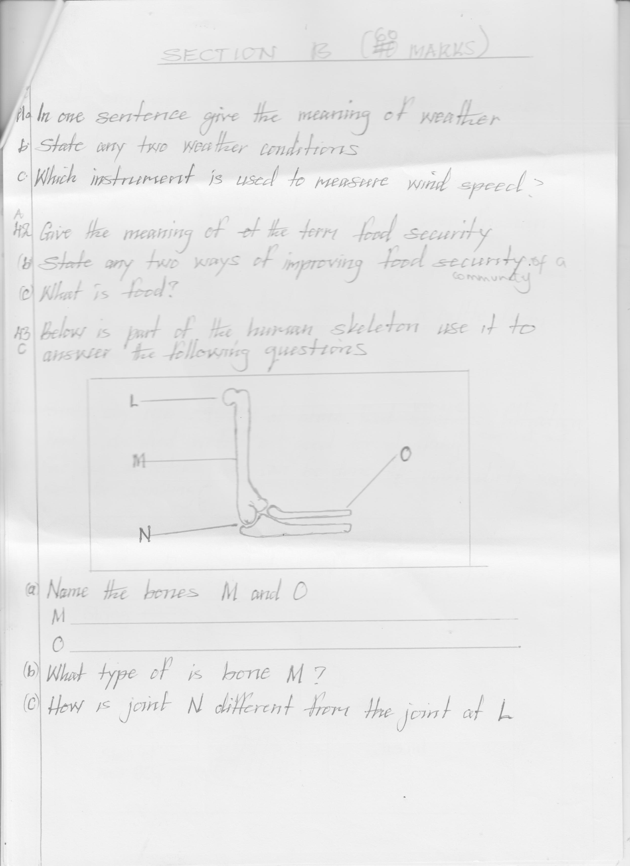

a) Name the bones M and O

i) M _________________________

ii) O _________________________

b) What type of bone is marked with letter M?

___________________________________________________

c) How is joint N different from the joint at L?

_____________________________________________________

1. a) State any two ways how vectors spread diseases.

i)____________________________________________________

ii)___________________________________________________

b) Cite out ant two diseases which are not spread by vectors.

i)____________________________________________________

ii)___________________________________________________

1. a) State the main reason why farmers keep Friesian cattle.

_____________________________________________________

b) Identify any other breed of cattle kept for the reason given in “a”

above.

_____________________________________________________

c) How are the following tools useful on a cattle farm?

i) strip cup

_____________________________________________________

ii)lactometer

____________________________________________________

1. a) State any one activity at home where filtration is carried out.

_____________________________________________________

b) Why is distilled water not good for drinking?

_____________________________________________________

c) Give two activities that can be done to make dirty water safe for

drinking. i)____________________________________________________

ii)___________________________________________________

1. **Study the diagram below of finding volume**

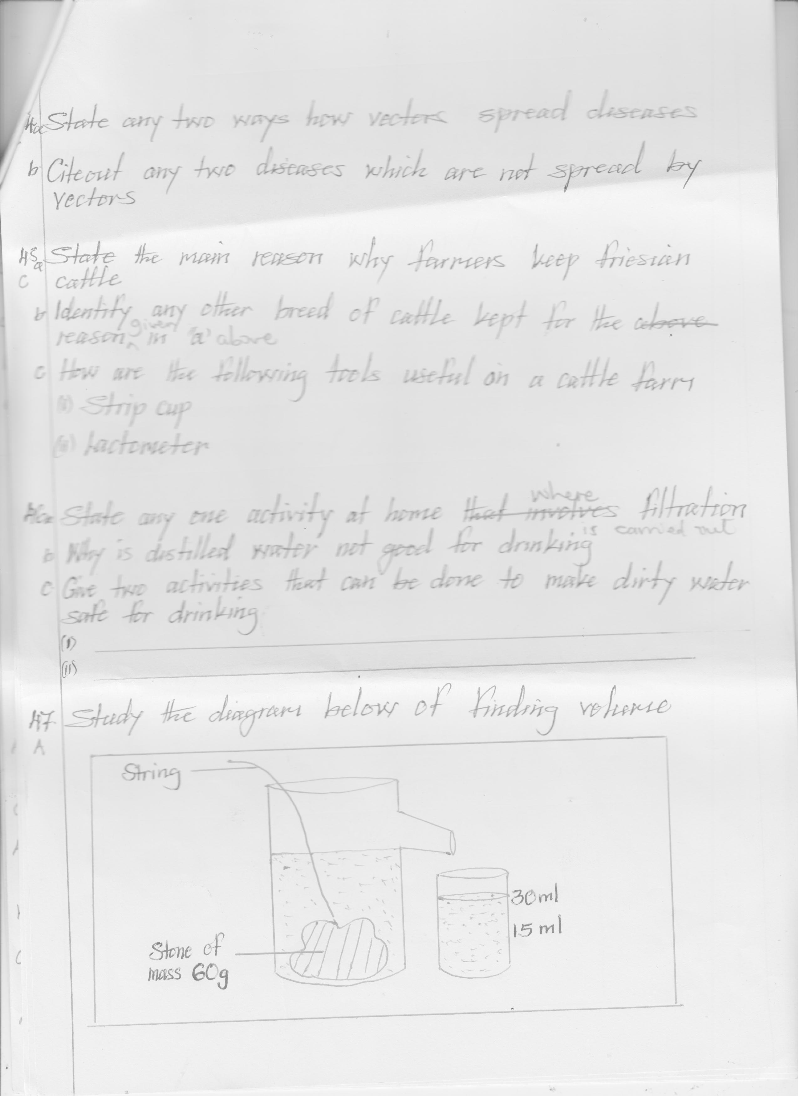

1. When is the above method used to measure volume?

_____________________________________________________

1. State the role of the string in the above process.

_____________________________________________________

1. Calculate the density of the stone (2marks)

_____________________________________________________

1. a) State the role of the following parts of the female reproductive

system.

1. Ovary

_____________________________________________________

1. Cervix

_____________________________________________________

1. Name any disease of the reproductive system which leads to insanity

___________________________________________________

1. State any one way of caring for the reproductive system.

_____________________________________________________

1. a) What is meant by the term PHC?

_____________________________________________________

b) Identify any two elements of PHC respected at school.

i)____________________________________________________

ii)___________________________________________________

c) Outline any one principle of PHC.

_____________________________________________________

1. **Study the diagram of the kidney below**

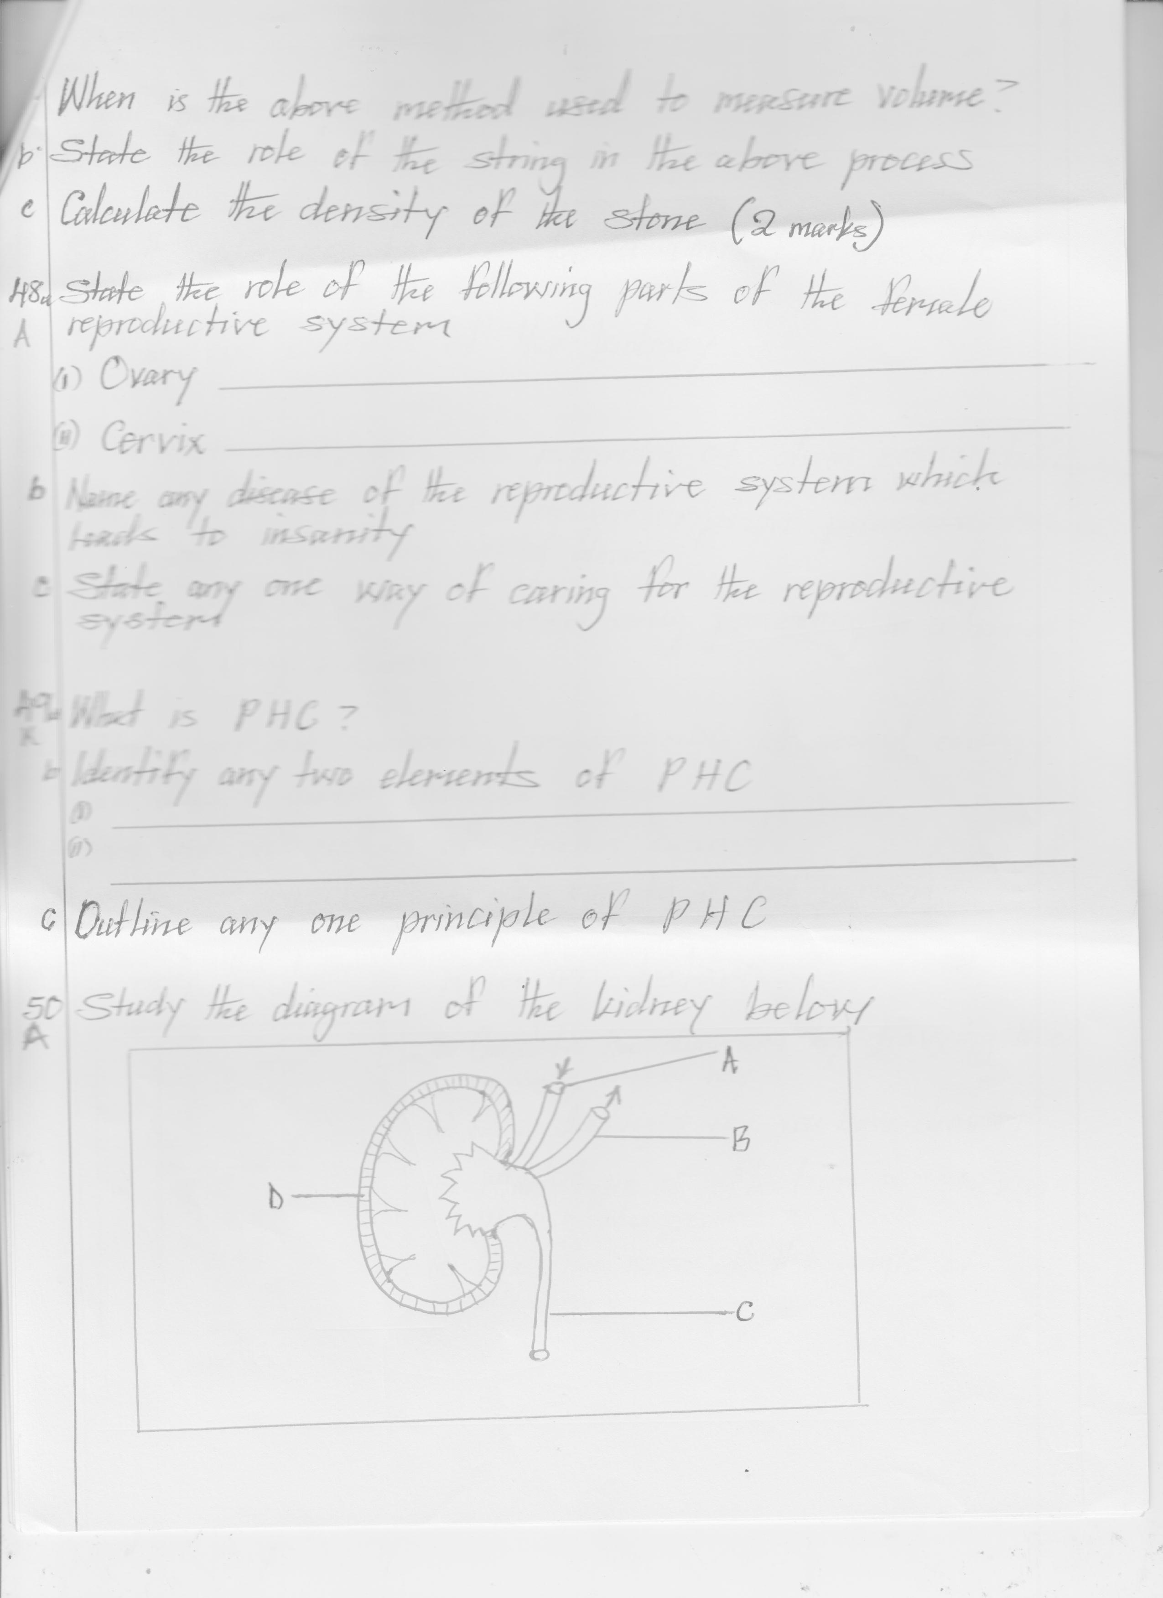

a) Name parts marked C and D

i) C _____________________ ii) D_______________________

b) Give one difference between blood carried in vessels marked A and B

____________________________________________________

____________________________________________________

c) List any one disease of the kidney. _____________________________________________________

1. a) In one sentence, give the meaning of drug prescription.

____________________________________________________

____________________________________________________

b) Which component of a drug prescription protects patients from taking

wrong drugs?

_____________________________________________________

c) How should a mother prevent drug poisoning in a home?

_____________________________________________________

d) What is drug misuse?

_____________________________________________________

_____________________________________________________

1. a) State any one economic importance of sound energy.

_____________________________________________________

b) How does a guitar produce sound?

_____________________________________________________

c) Give any one method of storing sound.

_____________________________________________________

d) State one importance of an ear to a deaf person.

_____________________________________________________

1. 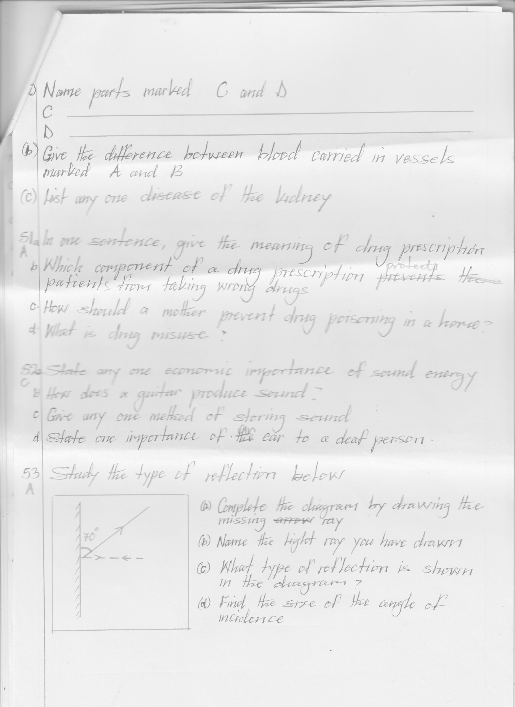 **Study the type of reflection below**

a) Complete the diagram by drawing the missing ray.

b) Name the light ray you have drawn

_____________________________________________________

c) What type of reflection is shown in the diagram?

____________________________________________________

d) Find the size of the angle of incidence

___________________________________________________

1. a) What is oral health?

____________________________________________________

____________________________________________________

1. Name any two tools that can be used to promote oral health.

i)____________________________________________________

ii)___________________________________________________

c) Why is opening bottles using one’s teeth a bad practice?

_____________________________________________________

1. **Match the following forms of electricity with their sources**

|  |  |
| --- | --- |
| **List A** | **List B** |
| Thermal electricity  Hydro electricity  Geothermal electricity  Solar electricity | The sun  Fossil fuels  First flowing water  Steam from hot rocks |

1. Thermal electricity ____________________________
2. Hydro electricity ____________________________
3. Geothermal electricity ____________________________
4. Solar electricity ____________________________

**END**